Sunday 21st December
10.30 Christmas Carol Service
Rev. Roger Collins
Christmas Carol Service at the Cotteridge Church
Sunday 21st December at 10.30
- Notices
- Processional 190 Angels from the Realms of Glory
  - Lighting the Advent Candle Hymn 164
  - Prayers of Penitence
- First Reading
  - The Prophecy of the Messiah’s birth Isaiah 9 2 6-7
  - It was to older folk that Jesus came
  - Hymn 178 Long ago
- Second Reading
  - The Annunciation of Mary Luke1 26-38
  - O Simplicitas – Madelin L’enge
  - Hymn 187 The Angel Gabriel
- Third Reading
  - The birth of Jesus Luke 2 1-7
  - The Barn Elizabeth Coatsworth
  - Hymn 216 See him lying on a bed of straw
- Fourth reading
  - The shepherds go to the manger Luke 2 8-16
  - The Shepherds Carol Norman Nicholson
  - Hymn While Shoppers shop tune On Ilkley Moor
- Fifth reading
  - Wise men led by a star to Jesus Matthew 2 1-11
  - They knelt at the manger Ira E. Williams
  - Hymn 224 As with Gladness
- Sixth reading
  - The incarnation of the Word of God John 1 1-14
  - Che Jesus Anonymous Argentina
  - Offertory hymn 222 Who would think that what was needed
- Intercessions
- Recessional 202 Hark the Herald angels sing
- Dismissal

14th December 2025
10.30 Holy Communion
Rev Tariro Mukoja We remember those who have diedThe Calling of the Cotteridge Church is to respond to the Gospel of God’s love in Christ and to live out its discipleship in worship and mission.

Lord Jesus, light of the world,
born in David’s city of Bethlehem,
born like him to be a king:
be born in our hearts at Christmas,
be King of our lives today.
Hymns 165 v1-3 175, 264,364,487 186
Reading Janet H Jane
Music John T
Sound Chen C
We remember our pastoral links
Dorothy and Stephen with David S
Pam with Chen Nicola d, Chris P Ruth Alison Timothy and Imogen S
We pray for those who are ill or are in need
Megan, Vinnie H, Mark T, Robin, Shirley, Jenny F, , Lauren D, Keith and May K Lyn, Dorothy T, Sue S Neil W David and Marion W, Maurice W, and Cal W., Gill


Eternal God,
as Mary waited for the birth of your Son,
so we wait for his coming in glory;
bring us through the birth pangs of this present age
to see, with her, our great salvation
in Jesus Christ our Lord.

Organist Bill C
sound Jane S
We remember our pastoral links
Dorothy and Stephen with David S
Pam with Chen Nicola d, Chris P Ruth Alison Timothy and Imogen S
We pray for those who are ill or are in need
Megan, Vinnie H, Mark T, Robin, Shirley, Jenny F, , Lauren D, Keith and May K Lyn, Dorothy T, Sue S Neil W David and Marion W, Maurice W, and Cal W., Gil O., Sally, Neil H Tilly M, Norman and Philomena, Eric, Jed S, Israel S Chris P Monica, Phil A
We remember those who have died.
The Calling of the Cotteridge Church is to respond to the Gospel of God’s love in Christ and to live out its discipleship in worship and mission.

This notice sheet is prepared by Roger to whom notice should be sent rev.rogercollins@thecotteridgechurch.org.uk

CALENDAR
Monday 22nd December
Tuesday 23rd December
9.00 Home start
10.00 Holy Communion
Rev Tariro Mukoja
6.00 Datus
Christmas at Cotteridge 2025

Wednesday 24th December
6.00 Carols on the Green
Bournville
Thursday 25th December
10.30 Christmas Communion
Rev Roger Collins
Coffee bar
10-12.
The Cotteridge Church
Assistant Priests
Rev Tariro Mukoja
Tariro Mukoja@thecotteridgechurch.org.
Farai Mapamula
farai.Mapamula@methodist.org.uk
Roger Collins 07721 526 854
Church Administrator Sarah Canning
Telephone 0121 433 5518 email
administrator@thecotteridgechurch.org.uk Tuesday Communions
30th Roger
Notices
Safeguarding "The Cotteridge Church is fully committed to ensuring the welfare of all children, young people and vulnerable adults who are part of this community. With this in mind, the Joint Church Council is looking to appoint a volunteer to oversee Safeguarding within the Church. The person appointed will be expected to share this commitment. No previous experience of Safeguarding is necessary, and appropriate training will be provided. If you feel you might be able to support and contribute to this important aspect of our Church's mission, and would like to learn more, then please speak, without commitment, to Tariro and Farai."
Treasurer
Are you called to serve your church? Volunteer Treasurer(s) needed. We, as the Cotteridge Joint Church Council, are seeking someone or a team to be our Treasurer(s) in the new year. The Treasurer (s) will work closely with the Trustees and the administrator to ensure we are pursuing our mission and achieving the agreed objectives through our churches financial strategy and management. If you are interested or want to hear more, grab us for a chat.
USED STAMPS
Please remember to save the stamps from the post for Birmingham City Mission. Place them in the red box by the door
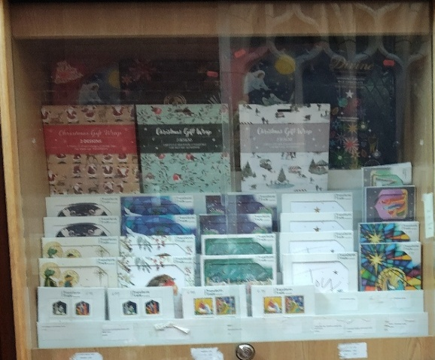
BOOKCENTRE


your last Chance to buy Christmas CardcardsCards Wrapping Paper Advent
Honey 8.00 Marmalade £3.20 Coffee 4.25
^{Zaytoun Olive OIL 25.50|}
^{Dates 6.00}
^{toilet rolls 1.05}
^{kitchen roll 2.85}
^{tissues 1.60}
Oxfam bite size Chocolate 1.85
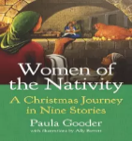


ADVENT READING


9 99. 10.99 10.95

4.95
B30 FOODBANK

Urgent needs
500g rice, tinned spaghetti, vegetables, soup, meat, meat products, rice pudding, fish (mackerel, tuna, sardines, salmon), baked beans, UHT semi-skimmed milk, UHT whole milk, chocolate bars, long-life juice, liquid soap, toothpaste, and gender-neutral shower gel.

g
4.5 million UK children now live in poverty. That's 31% of all children.

