

Sunday 7th June
to be announced
Parade and ALL AGE worship

God of truth,
help us to keep your law of love
and to walk in ways of wisdom,
that we may find true life

in Jesus Christ your Son.

Hymns
Readers Linda M, Janet H
Readings
Sound Boys Brigade
Music Peter C
Door Security Mike M

We remember our pastoral links for May
David S: with Dorothy and Stephen A. Doreen H: with Gordon and Lesley-Ann D., Eira H., Claudia R., Jane S., and Hai and Qi Zhang.,
We pray for those who are ill or are in need
Megan, Vinnie H, Mark T, Robin, Shirley, Jenny F, , Lauren D, Keith and May K Lyn, Dorothy T, Sue S Neil W David and Marion W, Maurice W, and Cal W., Gil O., Sally, Neil H Tilly M, Norman and Philomena, Eric, Jed S ,Israel S Chris P Monica, Ros M Harry M, Don and Sue H, Malcom, Kevin B, Sindy C , Richard,
We remember those who have died.
Mary Whetnall
The calling of the Cotteridge Church is to respond to the Gospel of God’s love in Christ and to live out its discipleship in worship and mission.

The-notice sheet is prepared by Roger to whom notices should be sent: roger@rrcollins.com
CALENDAR
Monday June 8st
6.00 Yoga
Tuesday June 9th
9.00 Home Start
100. Holy Communion
9th Israel Selvanayagam
6.00 Datus
6.00 Brownies Rainbow And Guides
Wednesday June 10th
11.00 Extend Exercise
7,.00 Games Club
Thursday June 11th
10.30 Knit And Natter
Friday June 12th
9.30 Saplings
6,00 Boys Brigade
Next Sunday
June 14th
10.30 Holy Communion
Rev Tariro Mukoja
10.30 Methodist District Worship
Coffee Bar 8.30 to 2.00 Weekdays
Saturdays 10-12
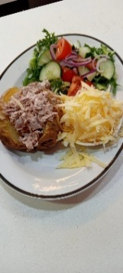
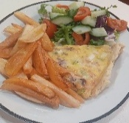
Here is some of the food available from the kitchen
A jacket potato with tuna, cheese and salad and also quiche with salad and chips.

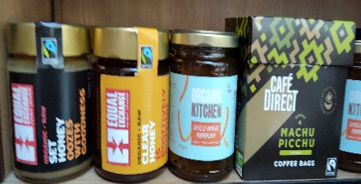
NOTICES
Tuesday Communions
16th ,23rd, 30th to be confirmed
Treasurer
Could you serve your church as Treasurer(s). The Cotteridge JCC is seeking someone or a team to be our Treasurer(s) this year, they will work closely with the Trustees and administrator to ensure we are achieving the agreed objectives through our church’s financial strategy and management. If you are interested or want to hear more, speak to Steve or Dorothy
Coming Together for Coffee and Cake
Please note in your diaries we will be having our next time together on Saturday 11th July from 10.30 until 12.00. Drop in when you can and share time together enjoying a drink and a slice Jane Stephens
The Cotteridge Church
Assistant Priests
Tariro Mukoja Tariro.mukoja@thecotteridgechurch.org.uk
Farai Mapamula
Farai.Mapamula@methodist.org.uk
Roger Collins 07721 526854
Israel Selvanayagam
Church Administrator Sarah Canning
Telephone 0121 433 5518 email
administrator@thecotteridgechurch.org.uk
BOOKCENTRE
Honey 8.00 Marmalade £3.20 Coffee


^{cooking oil 15.50}
^{dates 6.00}
^{toilet rolls 1.05}
^{kitchen roll k 2.85}
^{tissues 1.60}

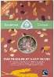
Please pay in to 30 96 12 account 02180482 or at the coffee bar till.
Normally 4.99
now only 2.50

B30 FOOD BANK

Our shopping list
Tinned soup
Tinned meat
Tinned fish
tinned vegetables peas carrots sweet corn
Tinned beans
Pasta and pasta sauces
tinned tomatoes
rice
instant kettle noodles or pasta
Weetabix porridge cereal 500g
Long life whole /semi skinned milk
squash
tea/coffee
Readymade custard
tinned rice pudding
tinned fruit peaches pineapple fruit cocktail
jam/honey
biscuits

Soap shampoo toothpaste toilet rolls Sanitary Towels fruit juice, Chocolate bars ,Cereals Gender neutral shower gel Washing up liquid and liquid/powder for clothes.

